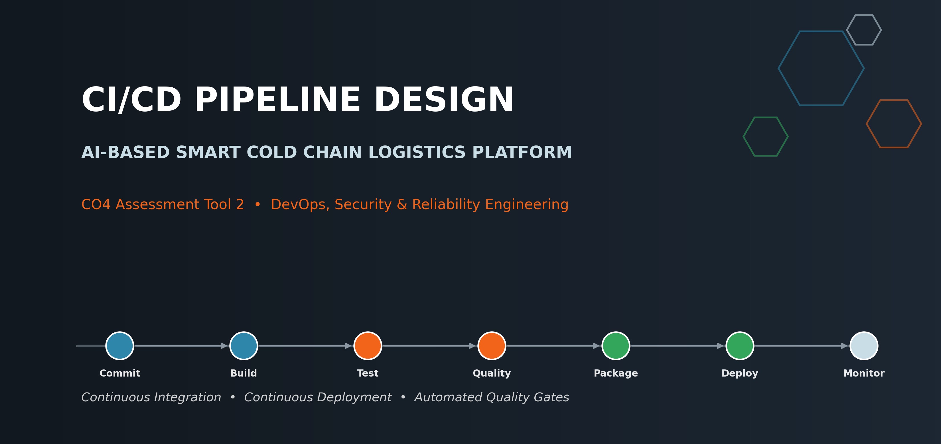

Student Name | Manisha
Register Number | 192424130
Programme | B.Tech — Artificial Intelligence & Data Science
Institution | Saveetha Institute of Medical and Technical Sciences (SIMATS Engineering)
Assessment | CO4 Assessment Tool 2 — CI/CD Pipeline Design Exercise
Assigned System | AI-Based Smart Cold Chain Logistics Monitoring and Optimization Platform

1. Requirement & CI/CD Needs Analysis
The AI-Based Smart Cold Chain Logistics Platform is made up of five independently deployable services (edge gateway, AI/ML prediction engine, backend API, dashboard frontend, and supporting infrastructure such as the message broker and database). Shipping code manually across five services — building each one, testing it, and deploying it by hand — does not scale as the team grows, and a mistake in a manual deployment could mean a vaccine shipment loses temperature monitoring in the field. A CI/CD pipeline is needed to remove that risk by automating integration, testing, and release consistently every single time.
Identified CI/CD Needs
Need | Why It Matters for This Platform
Automated build on every commit | Five services change independently; manual builds would be slow and error-prone.
Automated regression testing | A regression in the AI/ML failure-prediction logic could let a real equipment failure go undetected.
Code quality & security scanning | The platform handles shipment and sensor data; vulnerable dependencies or insecure code must be caught early.
Staged, gated deployment | Cold-chain data is safety-critical; changes must pass staging before reaching production traffic.
Fast, safe rollback | If a bad release reaches production, the team needs to restore service in minutes, not hours.
Visibility & notifications | Logistics operations run around the clock; the team must know immediately if a deployment fails.
Challenges of the Current Manual Process
Before this pipeline was designed, releases for the platform were built and pushed by hand: a developer would SSH into a server, pull the latest code, restart the service, and eyeball the logs to confirm nothing broke. This worked when there was one service and one developer, but it does not hold up as the platform has grown.
Manual Process | Risk Introduced | How CI/CD Removes It
Developer manually builds and copies files to the server. | Human error, inconsistent environments (“works on my machine”). | Every build runs in an identical, scripted CI environment.
Testing happens ad-hoc, sometimes skipped under deadline pressure. | Regressions reach production undetected. | Tests are mandatory pipeline gates that cannot be skipped.
No consistent review of dependencies for vulnerabilities. | Known-vulnerable packages silently ship to production. | Automated SAST/SCA scanning runs on every build.
Deployments happen directly to production with no staging step. | A bad change affects real shipments immediately. | Changes are proven in staging before a gated production release.
Rollback means manually redeploying an older code copy, if one is even kept. | Extended downtime during an incident. | One-command automatic rollback to the last known-good image.

2. Pipeline Architecture & Workflow
The pipeline is triggered on every push and pull request, and takes code from a developer's commit through build, automated testing, quality gates, packaging, staged deployment, and finally a controlled production rollout with monitoring and automatic rollback.
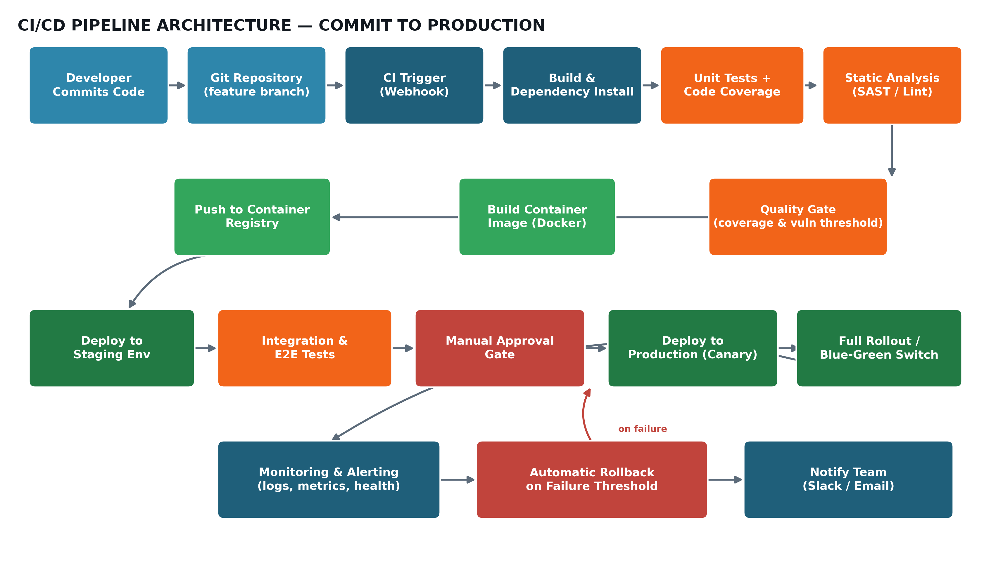
Figure 2.1 — End-to-end CI/CD pipeline architecture
Pipeline Stages Overview
Stage | Purpose
Source Code Management | Developers commit to feature branches; pull requests trigger the pipeline before merge to main.
Build | Installs dependencies and compiles/builds each affected service independently.
Automated Testing | Runs unit, integration and (later) end-to-end tests to catch regressions before release.
Code Quality Analysis | Static analysis, linting and security scanning enforce a minimum quality bar.
Packaging | Builds a versioned Docker image for the service and pushes it to a container registry.
Deployment | Promotes the image through staging and then production using gated, monitored releases.
How Branches Map to Pipeline Behaviour
The pipeline behaves differently depending on which branch triggered it, following the Gitflow model already established for this project (see the CO3 Git & Docker assignment). Short-lived feature branches only run checks; only develop, release and main branches are allowed to actually deploy anywhere.
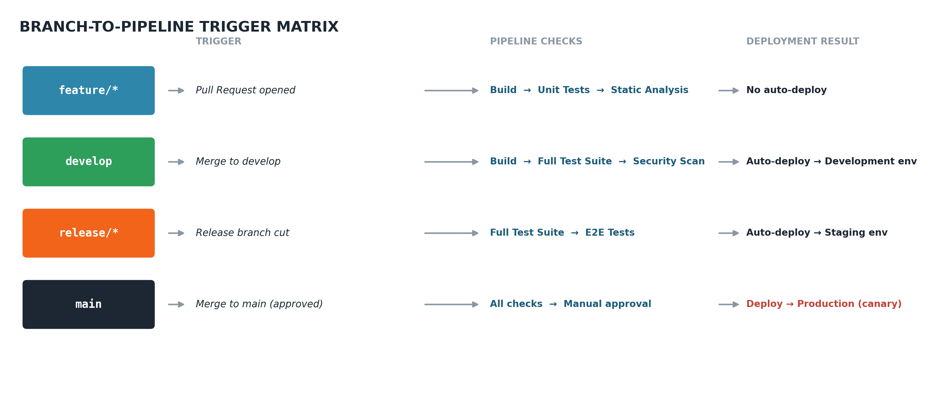
Figure 2.2 — Which pipeline actions each branch type triggers

3. Tools & Technology Selection
Each stage uses a widely adopted, well-documented tool so the pipeline is easy for any teammate to maintain, rather than relying on unfamiliar or niche tooling.
Stage | Tool | Justification
Source Control | GitHub | Already hosts the repository; native pull-request workflow and branch protection rules.
CI Orchestration | GitHub Actions | Tightly integrated with GitHub, free for the project's scale, and configured directly in-repo via YAML.
Build & Package | Docker / Docker Buildx | Matches the containerized architecture already used for deployment (see CO3 Docker assignment).
Unit & Integration Testing | pytest (AI/ML, edge gateway), Jest (backend API, dashboard) | Standard, fast test runners for Python and JavaScript with strong CI support.
Static Analysis / Linting | SonarQube, ESLint, Flake8 | Flags code smells, complexity and style issues before merge.
Security Scanning (SAST/SCA) | Bandit (Python), npm audit / Snyk | Detects insecure code patterns and vulnerable dependencies automatically.
Container Registry | Docker Hub (private repo) / Amazon ECR | Versioned, access-controlled storage for built images, pulled by the deployment stage.
Deployment Orchestration | Docker Compose (staging) / Kubernetes + Helm (production) | Compose keeps staging simple; Kubernetes gives production autoscaling, health checks and rolling updates.
Secrets Management | GitHub Encrypted Secrets / HashiCorp Vault | Keeps API keys and DB credentials out of source code and pipeline logs.
Monitoring & Alerting | Prometheus + Grafana | Tracks service health and sensor-ingestion latency; feeds the rollback decision.
Notifications | Slack Webhook / Email | Immediately informs the team of pipeline failures or completed deployments.

4. Automated Testing Strategy
Testing is layered as a pyramid so the pipeline gets fast feedback from cheap, numerous unit tests, with fewer, slower integration and end-to-end tests reserved for verifying that services work correctly together.
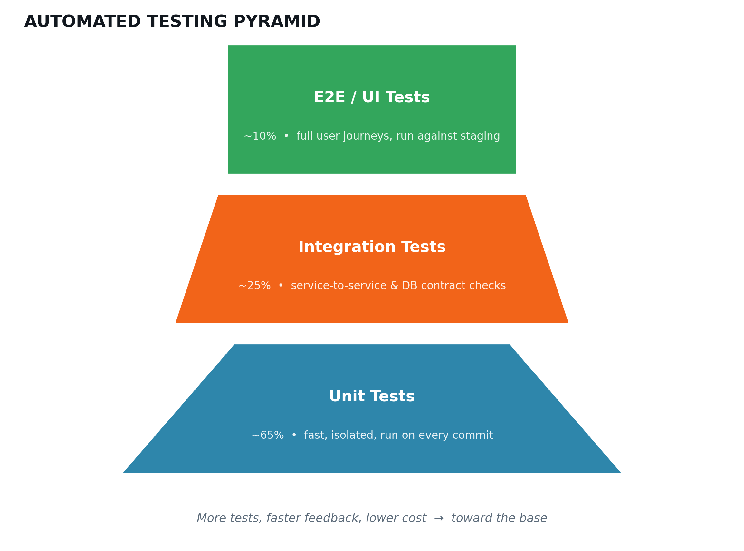
Figure 4.1 — Automated testing pyramid applied to the pipeline
Testing Strategy by Stage
Test Type | Tool | Runs When | What It Catches
Unit Tests | pytest / Jest | On every commit (CI build stage) | Broken functions, incorrect prediction logic, bad API handlers.
Integration Tests | pytest + testcontainers, Supertest | After build, before packaging | Service-to-service and database contract failures.
Security / Dependency Scan | Bandit, npm audit | Alongside static analysis | Known-vulnerable packages, insecure code patterns.
End-to-End (E2E) Tests | Playwright / Cypress | After deploy to staging | Broken user flows across the dashboard and backend together.
Smoke Tests | curl / health-check script | Immediately after production deploy | Confirms the new release is actually serving traffic correctly.

5. Deployment Strategy
Code is promoted through three progressively production-like environments, so problems are caught long before real shipments and sensors depend on the system.
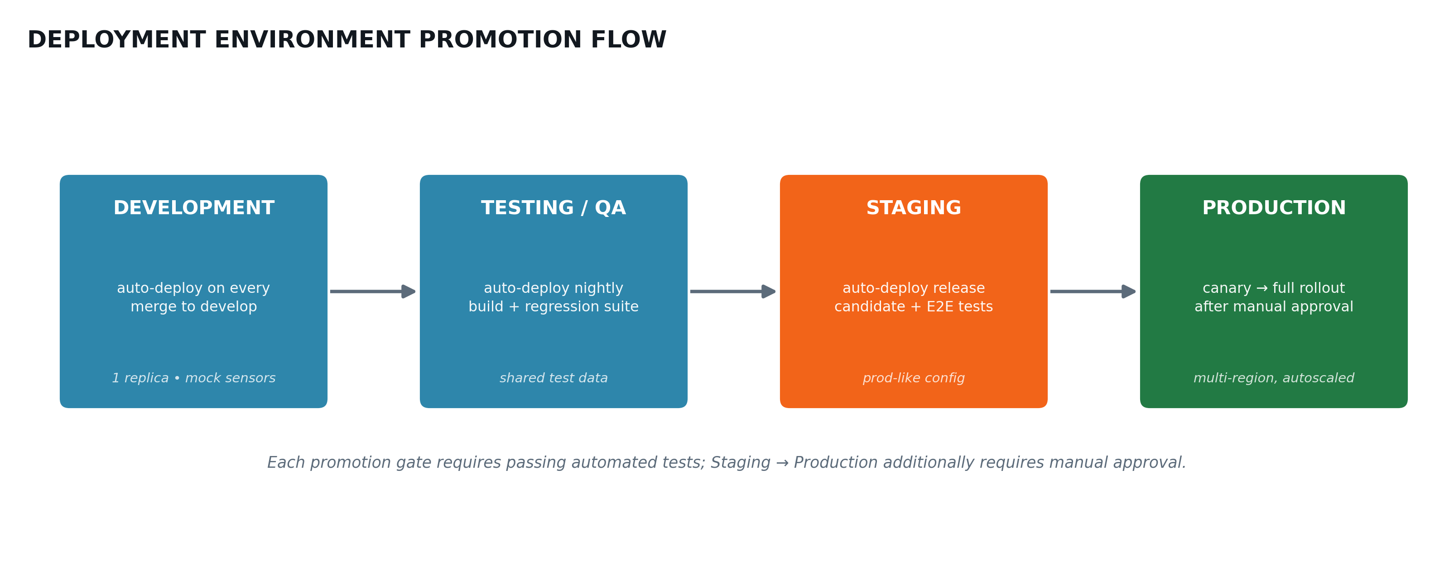
Figure 5.1 — Environment promotion flow from development to production
Environment | Purpose | Deployment Trigger
Development | Individual feature verification using mock sensor data. | Automatic on every merge to the develop branch.
Testing / Staging | Full regression and E2E testing against a production-like setup. | Automatic nightly build, plus every release candidate.
Production | Serves real cold-chain shipments and sensor traffic. | Manual approval gate, then canary release followed by full rollout.
Production releases use a canary strategy: the new version first receives a small slice of live traffic (for example, 10%) while monitoring closely, and only rolls out fully once error rates and latency stay within normal bounds — limiting the blast radius of any undetected issue.

6. Security, Quality Checks, Notifications & Rollback
Concern | Mechanism | Tool / Technique
Secrets protection | No credentials in source code; injected at runtime from encrypted storage. | GitHub Encrypted Secrets / Vault
Dependency security | Every build scans for known-vulnerable packages before packaging. | npm audit, Bandit, Snyk
Code quality gate | Merge is blocked if test coverage drops below threshold or lint errors exist. | SonarQube quality gate
Access control | Only reviewed, approved pull requests can merge to main and trigger production release. | GitHub branch protection rules
Production approval | A human must approve the promotion from staging to production. | Manual approval gate in pipeline
Health monitoring | Live error rate, latency and sensor-ingestion lag are tracked post-deploy. | Prometheus + Grafana dashboards
Automatic rollback | If health metrics breach threshold within the canary window, the previous stable image is redeployed automatically. | Kubernetes rollback / previous image tag
Team notification | Pipeline success, failure, and rollback events post immediately to the team channel. | Slack Webhook + email
What the Team Sees After a Deployment
The mockup below shows the kind of live dashboard the team watches during and immediately after a canary release — the same error rate, latency and sensor-ingestion metrics that feed the automatic rollback decision in Figure 2.1.
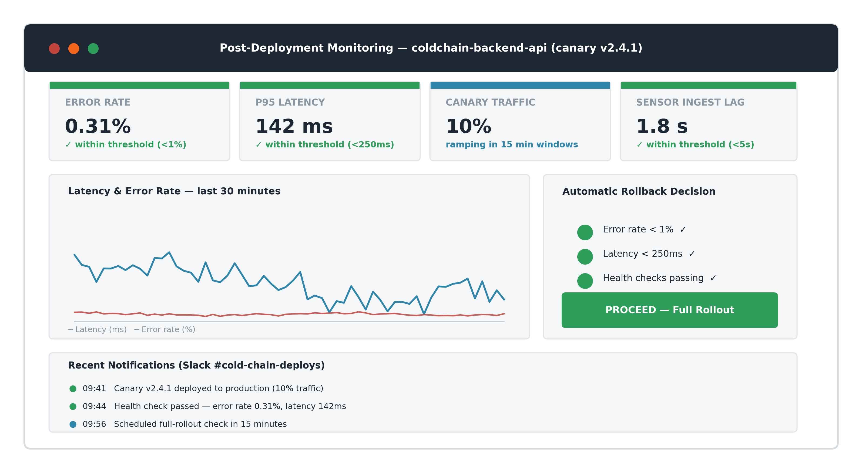
Figure 6.1 — Post-deployment monitoring dashboard during a canary release
Sample Pipeline Configuration (excerpt)
# .github/workflows/ci-cd.yml
name: cold-chain-ci-cd
on:
push:
branches: [develop, main]
pull_request:
branches: [develop, main]

jobs:
build-and-test:
runs-on: ubuntu-latest
steps:
- uses: actions/checkout@v4
- name: Install dependencies
run: pip install -r requirements.txt
- name: Run unit tests
run: pytest --cov=app --cov-report=xml
- name: Static analysis
run: bandit -r app/ && flake8 app/
- name: Build Docker image
run: docker build -t coldchain/backend-api:${{ github.sha }} .
- name: Push to registry
run: docker push coldchain/backend-api:${{ github.sha }}

deploy-staging:
needs: build-and-test
if: github.ref == 'refs/heads/develop'
steps:
- name: Deploy to staging
run: kubectl apply -f k8s/staging/ --record
- name: Run E2E tests
run: npx playwright test
- name: Notify team
run: ./scripts/notify_slack.sh "Staging deploy complete"

7. Pipeline Walkthrough — Commit to Production
Referring back to Figure 2.1, a single change moves through the pipeline as follows:
- A developer commits code to a feature branch and opens a pull request into develop.
- The CI trigger (GitHub Actions webhook) fires automatically on the pull request.
- The build stage installs dependencies and compiles the affected service.
- Unit tests and code coverage run; the build fails fast if any test breaks.
- Static analysis and security scanning (SAST/SCA) check for code smells and vulnerable dependencies.
- A quality gate blocks the pipeline if coverage or vulnerability thresholds are not met.
- A versioned Docker image is built and pushed to the container registry.
- The image is automatically deployed to the staging environment.
- Integration and end-to-end tests run against staging to confirm the services work together correctly.
- A manual approval gate requires a lead/reviewer to authorize the production release.
- The image is deployed to production as a canary release, receiving a small slice of live traffic.
- Monitoring and alerting watch error rate and latency during the canary window.
- If metrics stay healthy, the release rolls out fully (blue-green switch); if not, automatic rollback restores the previous stable image and the team is notified immediately via Slack/email.

Key Benefits & Future Enhancements
Key Benefits of This Pipeline
Benefit | How the Pipeline Delivers It
Speed | A change reaches staging automatically within minutes of merge, instead of a manual multi-hour release process.
Consistency | Every build runs the same scripted steps, removing “works on my machine” discrepancies between developers.
Quality | Mandatory test and coverage gates mean broken code cannot silently reach production.
Security | Dependency and static-analysis scanning catch vulnerabilities before they ship, not after an incident.
Reliability | Canary releases and automatic rollback limit the impact of any regression that slips through.
Team Confidence | Real-time notifications and dashboards mean nobody has to guess whether a release succeeded.
Planned Future Enhancements
- Add chaos-engineering tests (e.g. randomly killing a container) to verify the platform tolerates real-world failures, not just code bugs.
- Introduce progressive delivery with automated canary analysis (comparing error/latency metrics statistically) instead of fixed thresholds.
- Extend security scanning to container images themselves (e.g. Trivy) in addition to source-code dependencies.
- Add multi-region deployment so the platform keeps monitoring cold chains even if one cloud region has an outage.
- Track deployment frequency and change-failure rate (DORA metrics) to measure how the pipeline improves over each semester.

Conclusion
This CI/CD pipeline design automates the AI-Based Smart Cold Chain Logistics Platform's journey from a developer's commit to a monitored production release. By layering automated testing, static and dependency security scanning, staged environments, and a canary deployment with automatic rollback, the pipeline directly supports CO4's emphasis on security, reliability, and ethics: defects and vulnerabilities are caught before they reach real shipments, production changes are gated by human review, and the team is notified the moment something goes wrong — so a temperature-sensitive shipment is never left unmonitored because of a bad deployment.

